HEATER OPENING
IN DEGREE

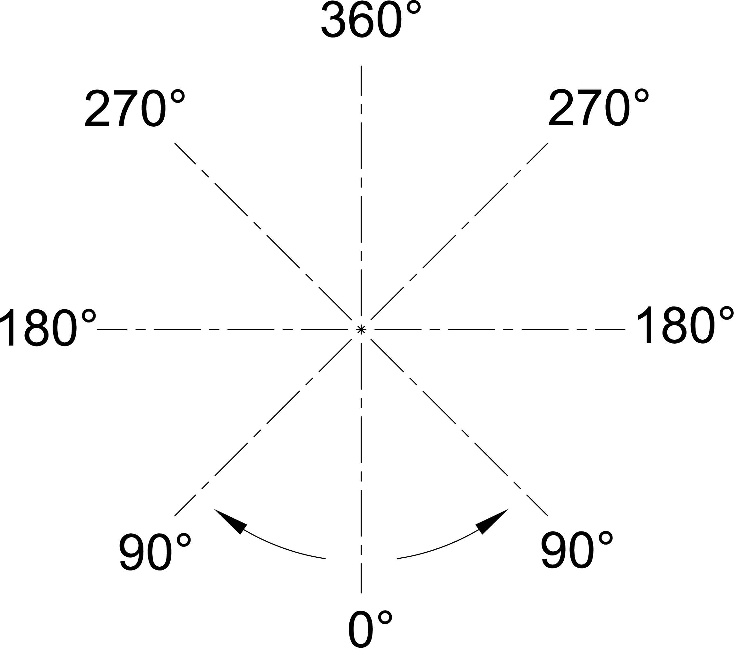

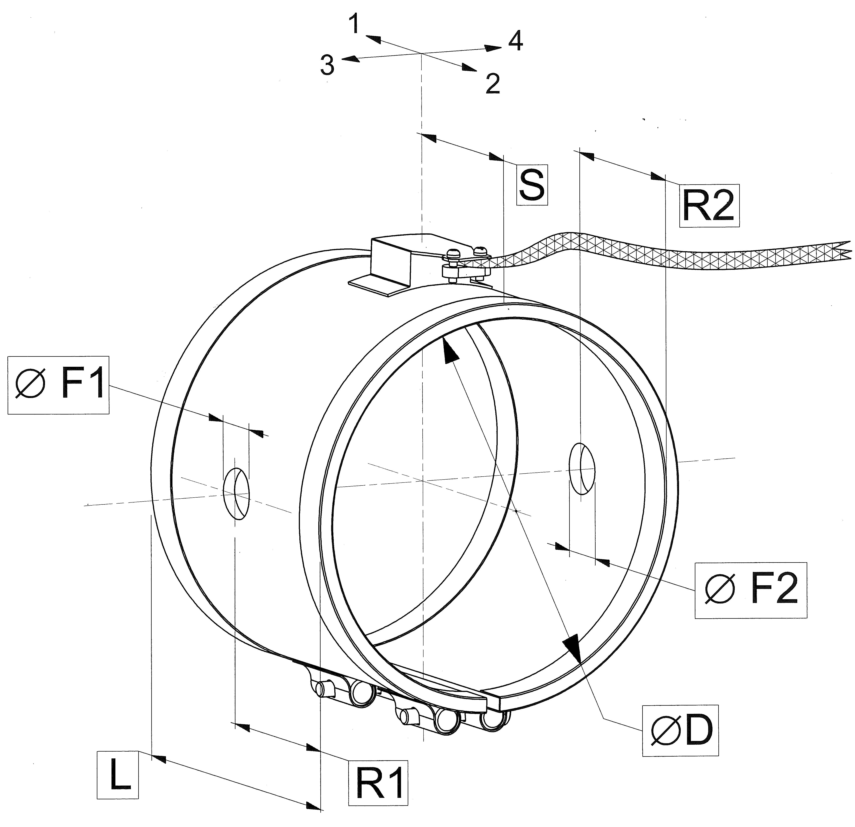
CABLE EXIT DIRECTION

TERMINAL BOX CONNECTION
AND HOLE POSITION

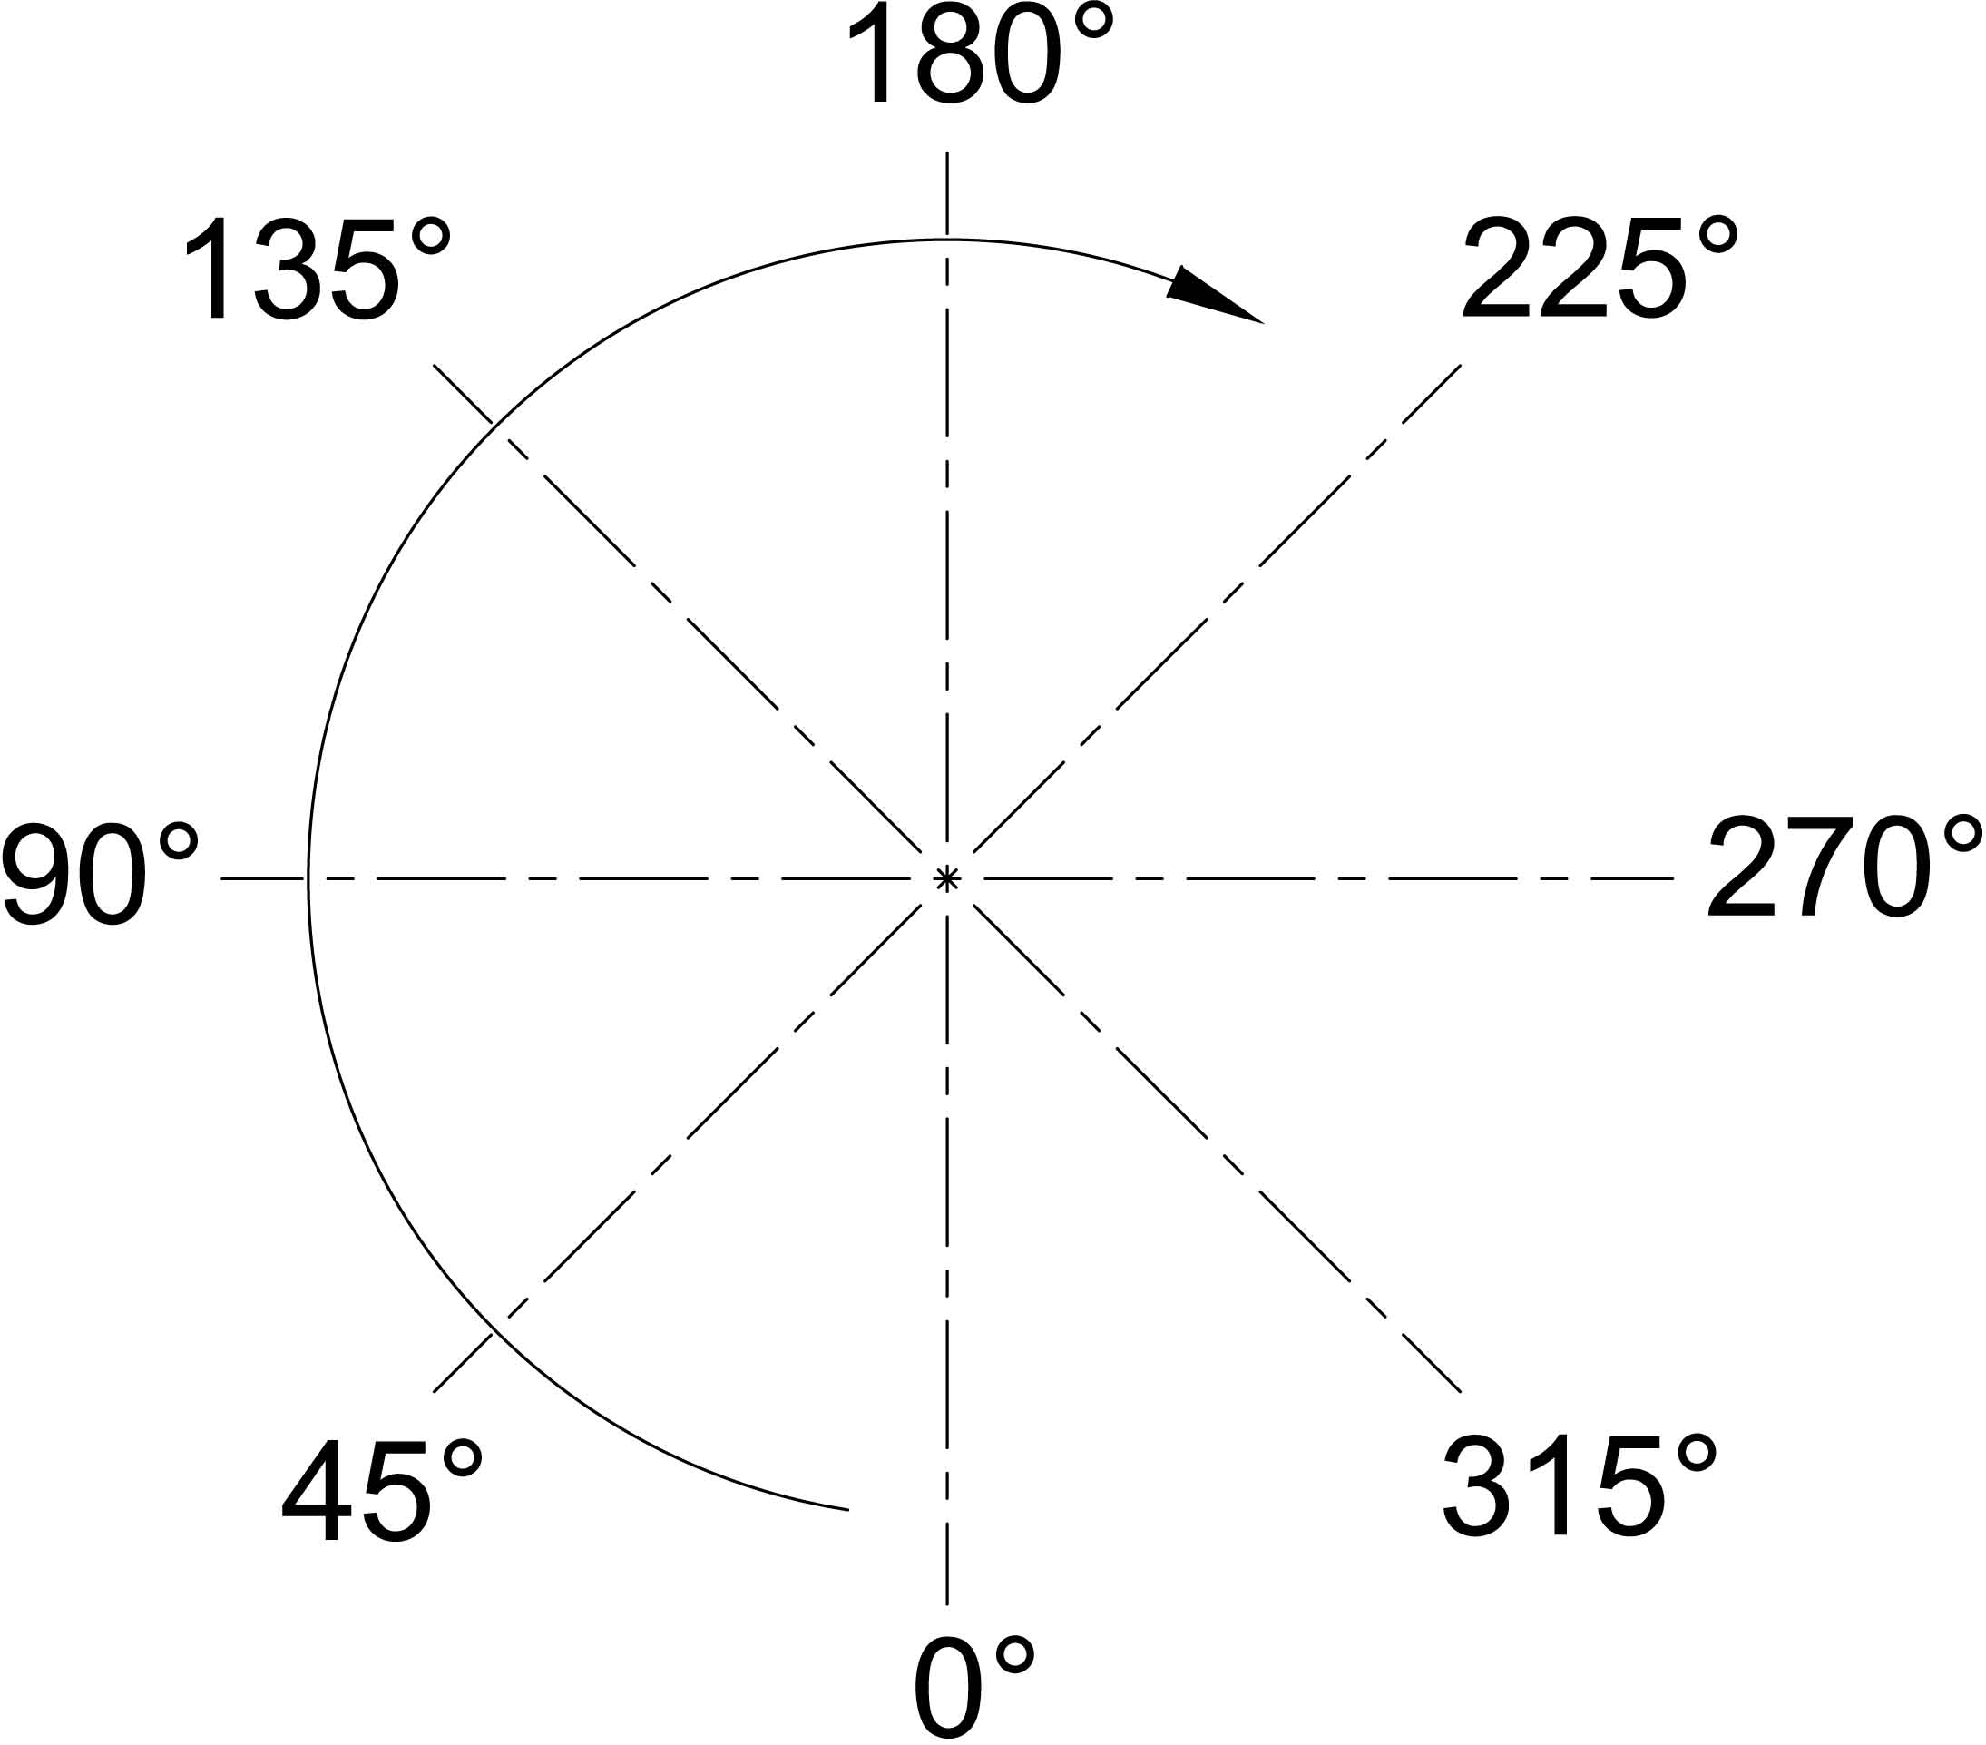

DEFINITION SIDE

Diameter ØD
Length L
Voltage supply [V]
Power [W]
Kind of board
Position of Board in degree |  |  |  |  |  | Dimension S
Cable exit direction [1-2-3-4]
Cable length
Heater opening in degree |  |  |  |  | Unless indication: 0°
Hole 1 position in degree |  | Dimension R1 |  |  |  |  | Dimension ØF1
Hole 2 position in degree |  | Dimension R2 |  |  |  |  | Dimension ØF2
Hole 3 position in degree |  | Dimension R3 |  |  |  |  | Dimension ØF3
Hole 4 position in degree |  | Dimension R4 |  |  |  |  | Dimension ØF4
Hole 5 position in degree |  | Dimension R5 |  |  |  |  | Dimension ØF5
All the dimension without measurement units are in [mm]

